Robust clipped correlation: GBPUSD and EURGBP
Method 04 / daily log returns clipped at ±0.01, ±0.02, ±0.03 / Alpari D1 full available history

Study setup
Logical pair: GBPUSD , EURGBP
Broker symbols: GBPUSD_i , EURGBP_i
Snapshot: 2026-11-03_majors_alpari_D1
Timeframe: D1
Matched return window: 1999-01-06 to 2026-11-02 (UTC bar dates)
Matched return count n: 7199
Dropped unfinished last bar dated 2026-11-03 UTC after a tick-volume check against the prior complete day.
Clip bounds c in log-return units: 0.01, 0.02, 0.03 (about ±1%, ±2%, ±3% on the log scale). Headline c = 0.02.
Clipping caps a day's magnitude at ±c and keeps the row; it does not drop the day, so n is the same at every c.
Complete matched rows (Excel): GBPUSD-EURGBP_Clipped_D1.xlsx
Complete matched rows (HTML table): GBPUSD-EURGBP_Clipped_D1_data.html

Method carried forward
Each matched daily log return of close, ln(close_t / close_t-1), is clipped in the broker quote direction before Pearson correlation: x_tilde = min(c, max(-c, x)) and y_tilde = min(c, max(-c, y)), then rho_clip = Pearson(x_tilde, y_tilde) on the same rows as raw Pearson r. Quotes are not inverted. A day beyond ±c stays in the sample at the cap; n does not change. rho_clip is symmetric under swap of the two symbols. rho_clip = 0 means no straight-line link among the clipped values in this sample; it does not mean no link of any kind. The score is not a cause, not a lead, and not a trading signal. Daily rows are not independent draws, so the two-sided p-value and Fisher interval are reported and treated as secondary to rho_clip. Cap-hit counts (|log return| > c) flag how much of each leg was capped.

Raw Pearson on the same rows
Pearson r: -0.397845
Two-sided p-value: 1.22348e-271
Approximate 95% Fisher interval: [-0.417112, -0.378221]
This is the unclipped comparison required by the method. The headline score is rho_clip at c = 0.02 below.

Clipped results
n = 7199 at every c. Headline row is c = 0.02. Cap-hit count is the number of days with |log return| > c before clipping.
c | rho_clip | p | ci_low | ci_high | rho_minus_r | GBPUSD_cap_hits | EURGBP_cap_hits | GBPUSD_cap_share | EURGBP_cap_share
0.01 | -0.339619 | 8.2250546e-194 | -0.35989593 | -0.31902092 | 0.058226437 | 511 | 344 | 0.070982 | 0.047784
0.02 | -0.369638 | 6.4010538e-232 | -0.38941325 | -0.34952153 | 0.028207497 | 39 | 18 | 0.005417 | 0.0025
0.03 | -0.381804 | 1.4320943e-248 | -0.40136421 | -0.36189469 | 0.016041692 | 11 | 3 | 0.001528 | 0.000417

Conclusion
Over 7199 matched daily log-return rows for GBPUSD and EURGBP (broker quote directions unchanged), headline robust clipped correlation at c=0.02 is -0.3696 (negative, weak straight-line association among clipped values in this sample). Approximate 95% Fisher interval on the clipped series: [-0.3894, -0.3495]. Same-sample raw Pearson r is -0.3978 (rho_clip minus r = 0.0282). Sensitivity across the fixed grid: c=0.01 same sign; c=0.02 same sign; c=0.03 same sign. Two-sided p under the usual independent bivariate-normal model is 6.401e-232; that model does not match linked daily FX returns, so treat p as secondary. This does not establish cause, lead-lag, or a lasting trading rule.

What to look at in this file next time
1) rho_clip at c = 0.02 versus raw Pearson r. 2) Whether c = 0.01 and c = 0.03 keep the same sign as 0.02. 3) Cap-hit counts before treating a large gap as settled. 4) The ±0.02 lines on the returns chart and the clip box on the scatter.

Charts
Daily closes

Daily log returns with +/- 0.02 clip lines
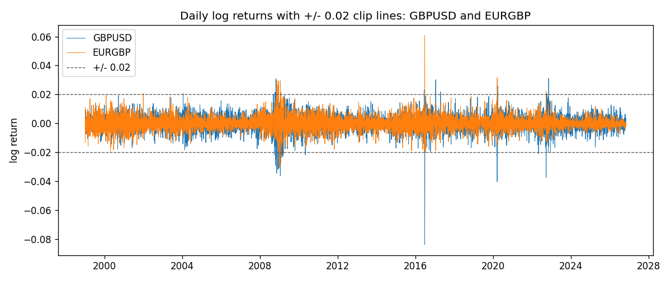
Log-return scatter with +/- 0.02 clip box
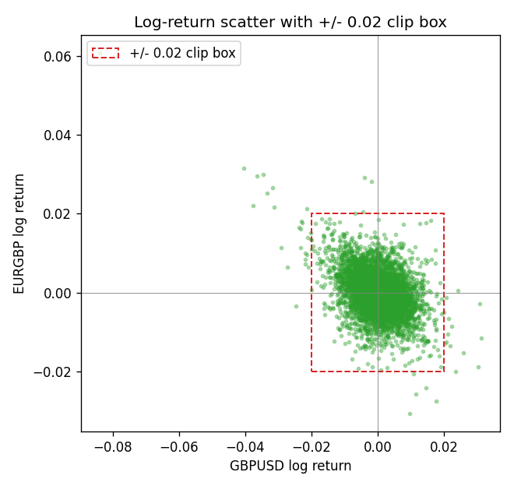

Data report
Every matched row that entered the clipped and raw correlations is stored in the sibling Excel workbook named GBPUSD-EURGBP_Clipped_D1.xlsx. That file is the complete data archive for redrawing charts. Embedding all rows as a Word table is impractical at this length; the Word file holds the column list, column summaries, and the first and last 15 matched rows.
Columns: time, GBPUSD_open, EURGBP_open, GBPUSD_high, EURGBP_high, GBPUSD_low, EURGBP_low, GBPUSD_close, EURGBP_close, GBPUSD_tick_volume, EURGBP_tick_volume, GBPUSD_spread, EURGBP_spread, GBPUSD_real_volume, EURGBP_real_volume, GBPUSD_log_return, EURGBP_log_return, GBPUSD_log_return_clip_0p01, EURGBP_log_return_clip_0p01, GBPUSD_log_return_clip_0p02, EURGBP_log_return_clip_0p02, GBPUSD_log_return_clip_0p03, EURGBP_log_return_clip_0p03
Column summaries (matched calculation rows)
column | count | mean | std | min | 25% | 50% | 75% | max
GBPUSD_open | 7199 | 1.5160931 | 0.21831499 | 1.06854 | 1.324955 | 1.5114 | 1.63186 | 2.1066
EURGBP_open | 7199 | 0.78665041 | 0.09676322 | 0.5734 | 0.6873 | 0.83367 | 0.865175 | 0.9769
GBPUSD_high | 7199 | 1.5223838 | 0.21887686 | 1.08366 | 1.32978 | 1.5181 | 1.6384 | 2.1161
EURGBP_high | 7199 | 0.78972718 | 0.09713886 | 0.5789 | 0.68935 | 0.83657 | 0.86804 | 0.9799
GBPUSD_low | 7199 | 1.5097628 | 0.21753729 | 1.03518 | 1.3194 | 1.50323 | 1.62442 | 2.0983
EURGBP_low | 7199 | 0.78395066 | 0.09658082 | 0.5682 | 0.6853 | 0.83147 | 0.862765 | 0.9661
GBPUSD_close | 7199 | 1.5161471 | 0.21826306 | 1.06879 | 1.325055 | 1.51122 | 1.63216 | 2.1065
EURGBP_close | 7199 | 0.78669405 | 0.09676312 | 0.5735 | 0.6875 | 0.8337 | 0.86528 | 0.977
GBPUSD_tick_volume | 7199 | 94850.986 | 153561.38 | 62 | 9998.5 | 52911 | 91818.5 | 1273370
EURGBP_tick_volume | 7199 | 86949.029 | 145390.09 | 154 | 6517.5 | 44265 | 81326 | 1424684
GBPUSD_spread | 7199 | 26.96055 | 19.19062 | 0 | 11 | 20 | 50 | 50
EURGBP_spread | 7199 | 21.393666 | 19.14328 | 0 | 4 | 13 | 50 | 50
GBPUSD_real_volume | 7199 | 3.5570778e+09 | 8.4449923e+10 | 0 | 0 | 0 | 0 | 2.4038164e+12
EURGBP_real_volume | 7199 | 2.7805214e+10 | 1.3507095e+11 | 0 | 0 | 0 | 0 | 3.5726265e+12
GBPUSD_log_return | 7199 | -3.133e-05 | 0.00564236 | -0.08388241 | -0.00313644 | 2.978e-05 | 0.00317207 | 0.03112653
EURGBP_log_return | 7199 | 2.179e-05 | 0.00487166 | -0.03067367 | -0.0026225 | -0.00010035 | 0.00256076 | 0.06075387
GBPUSD_log_return_clip_0p01 | 7199 | 8.93e-06 | 0.00484378 | -0.01 | -0.00313644 | 2.978e-05 | 0.00317207 | 0.01
EURGBP_log_return_clip_0p01 | 7199 | -8.8e-07 | 0.00435218 | -0.01 | -0.0026225 | -0.00010035 | 0.00256076 | 0.01
GBPUSD_log_return_clip_0p02 | 7199 | -8.55e-06 | 0.00542586 | -0.02 | -0.00313644 | 2.978e-05 | 0.00317207 | 0.02
EURGBP_log_return_clip_0p02 | 7199 | 1.1e-05 | 0.00475862 | -0.02 | -0.0026225 | -0.00010035 | 0.00256076 | 0.02
GBPUSD_log_return_clip_0p03 | 7199 | -1.92e-05 | 0.00553483 | -0.03 | -0.00313644 | 2.978e-05 | 0.00317207 | 0.03
EURGBP_log_return_clip_0p03 | 7199 | 1.74e-05 | 0.00482984 | -0.03 | -0.0026225 | -0.00010035 | 0.00256076 | 0.03
First 15 matched rows (selected columns)
time | GBPUSD_close | EURGBP_close | GBPUSD_log_return | EURGBP_log_return | GBPUSD_log_return_clip_0p02 | EURGBP_log_return_clip_0p02
1999-01-06 | 1.6537 | 0.7019 | -0.00060452184 | -0.013303338 | -0.00060452184 | -0.013303338
1999-01-07 | 1.6502 | 0.7097 | -0.002118709 | 0.011051402 | -0.002118709 | 0.011051402
1999-01-08 | 1.6405 | 0.7062 | -0.0058954193 | -0.004943862 | -0.0058954193 | -0.004943862
1999-01-11 | 1.6312 | 0.7053 | -0.0056851331 | -0.0012752393 | -0.0056851331 | -0.0012752393
1999-01-12 | 1.6349 | 0.7077 | 0.0022657001 | 0.0033970309 | 0.0022657001 | 0.0033970309
1999-01-13 | 1.6499 | 0.708 | 0.0091330396 | 0.00042381861 | 0.0091330396 | 0.00042381861
1999-01-14 | 1.6531 | 0.7066 | 0.0019376331 | -0.0019793588 | 0.0019376331 | -0.0019793588
1999-01-15 | 1.6502 | 0.7012 | -0.0017558204 | -0.0076715819 | -0.0017558204 | -0.0076715819
1999-01-18 | 1.6522 | 0.7017 | 0.0012112405 | 0.00071280921 | 0.0012112405 | 0.00071280921
1999-01-19 | 1.6553 | 0.7007 | 0.0018745281 | -0.0014261269 | 0.0018745281 | -0.0014261269
1999-01-20 | 1.6472 | 0.7021 | -0.0049053846 | 0.0019960086 | -0.0049053846 | 0.0019960086
1999-01-21 | 1.6524 | 0.7016 | 0.0031518998 | -0.00071240297 | 0.0031518998 | -0.00071240297
1999-01-22 | 1.6565 | 0.7004 | 0.0024781662 | -0.0017118406 | 0.0024781662 | -0.0017118406
1999-01-25 | 1.6585 | 0.6966 | 0.0012066366 | -0.0054402425 | 0.0012066366 | -0.0054402425
1999-01-26 | 1.6597 | 0.6962 | 0.00072328374 | -0.00057438255 | 0.00072328374 | -0.00057438255
Last 15 matched rows (selected columns)
time | GBPUSD_close | EURGBP_close | GBPUSD_log_return | EURGBP_log_return | GBPUSD_log_return_clip_0p02 | EURGBP_log_return_clip_0p02
2026-10-13 | 1.32534 | 0.84458 | 0.0036434319 | 0.00020130374 | 0.0036434319 | 0.00020130374
2026-10-14 | 1.31884 | 0.84553 | -0.0049164679 | 0.0011241873 | -0.0049164679 | 0.0011241873
2026-10-15 | 1.32757 | 0.84479 | 0.0065976411 | -0.00087557391 | 0.0065976411 | -0.00087557391
2026-10-16 | 1.33257 | 0.84307 | 0.0037592051 | -0.0020380844 | 0.0037592051 | -0.0020380844
2026-10-19 | 1.33024 | 0.84259 | -0.0017500314 | -0.00056950988 | -0.0017500314 | -0.00056950988
2026-10-20 | 1.3377 | 0.83957 | 0.0055923442 | -0.0035906254 | 0.0055923442 | -0.0035906254
2026-10-21 | 1.33937 | 0.83839 | 0.0012476328 | -0.00140647 | 0.0012476328 | -0.00140647
2026-10-22 | 1.33967 | 0.83682 | 0.00022396082 | -0.0018743924 | 0.00022396082 | -0.0018743924
2026-10-23 | 1.33684 | 0.83751 | -0.0021146949 | 0.00082421033 | -0.0021146949 | 0.00082421033
2026-10-26 | 1.33359 | 0.83762 | -0.0024340661 | 0.00013133309 | -0.0024340661 | 0.00013133309
2026-10-27 | 1.33044 | 0.83595 | -0.0023648393 | -0.0019957343 | -0.0023648393 | -0.0019957343
2026-10-28 | 1.33254 | 0.83651 | 0.0015771808 | 0.00066967224 | 0.0015771808 | 0.00066967224
2026-10-29 | 1.33733 | 0.83553 | 0.0035881935 | -0.0011722209 | 0.0035881935 | -0.0011722209
2026-10-30 | 1.33913 | 0.83351 | 0.0013450605 | -0.0024205543 | 0.0013450605 | -0.0024205543
2026-11-02 | 1.3406 | 0.83426 | 0.0010971256 | 0.00089940465 | 0.0010971256 | 0.00089940465

